Day 1:

Setting the main functionalities of the web app (what should it allow the user to do):

-Log in
-Create groups of users
-Add to groups of users
-User permission levels management to group
-Post bugs to group
-See bugs from group
-Sort bugs from group
-Search bugs from group
-Close bugs
-Sort bugs into priorities
-Assign users to bugs
-Set deadlines for bugs
-Tag bugs
-Create tags
-Comment under bug posts

Layout of the software:

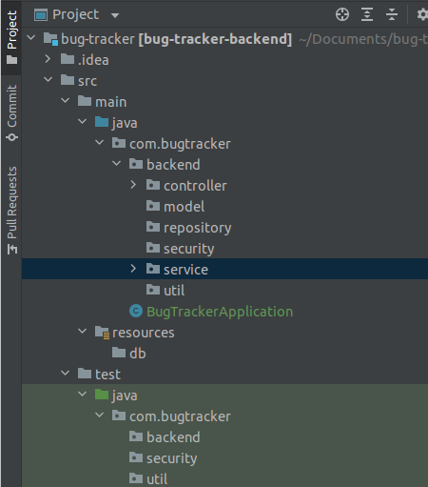

Controller --> This is where we will be mapping the URL addresses of the web service.
This is where we handle incoming requests by the client.
e.g.: get request from URL: domain/bug/{bugId}.

We could write a method that receives this request, understands the bugId variable, pulls the details of the bug from the database, formats it into an object(model) and returns the necessary data to the front end to be displayed.

The controller is the brain, this is where the logic takes place using the “tools/methods” we put in mainly [service].

Model --> This is where the classes which are going to be mapped to tables in the database go. As well as enums.

Repository --> Everything that requires communication with the database goes here. Such as queries. This is the access point to the database of the project.

Security --> All things related to Auth0, ignore for now

Service --> This is where methods that we will be using in controller go.
Example:
GetBug(@NoNull long bugId);
FindAllIssuesByGroup(@NoNull long Id);
So this is where methods for requests are built. Service communicates with the [repository] && [model] to either format and return data or edit/delete data on the database

This is not final

